DO ALL OF THESE CHANGES
Benny!
Here are some additional changes I would like you to implement:

Can we add the instagram links on everyone’s page:
Mine: @areksellsre
Travis: @travislipinskitherealtor
Jake: @Jakethefishdaddy
Abby: @abbydudarewicz
Carolyn: @bronxette

Can you please add this link to Jake’s page:
https://www.totalmortgage.com/bankers/jake-earl

For Jake we also need to add this info somewhere:
VP, Mortgage Banker
NMLS #975556

Branch Address
128 Garden Street
Farmington, CT 06032
Branch NMLS #2587938

Please remove the “About” button on top and that whole page.
Change “Stories” to “Insights” and “Find Agents” to “Meet Agents”
Remove “Why Us” button from the bar (but keep the section)

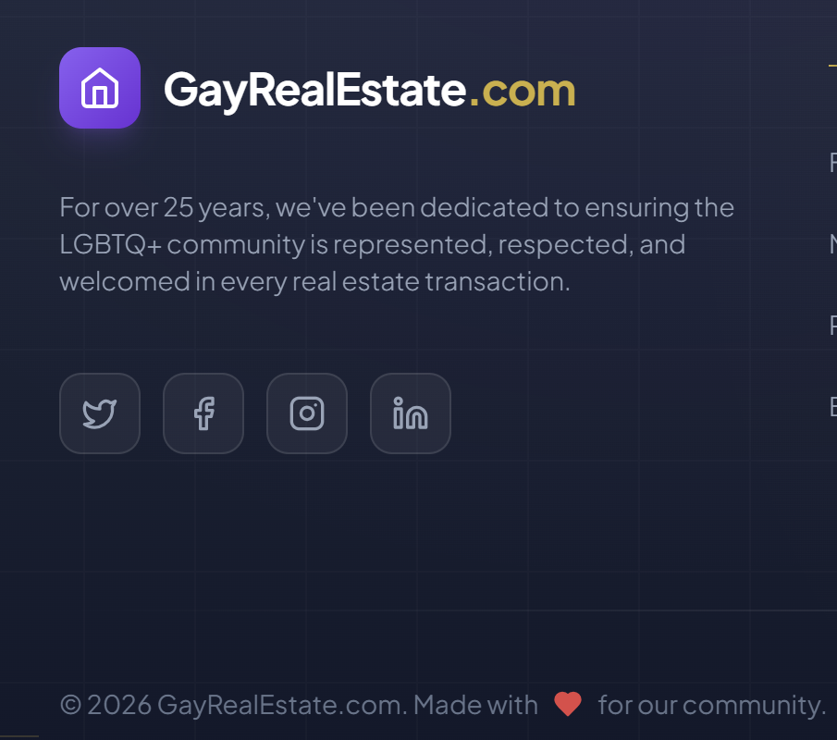

We are GayRealEstateCT (and the domain we have is gayrealestatect.net)
GayRealEstate.com is our biggest competition :)
Please remove that whole section with the social media links
Change the bottom text to: © 2026 GayRealEstateCT.net Made with <3 for our community.

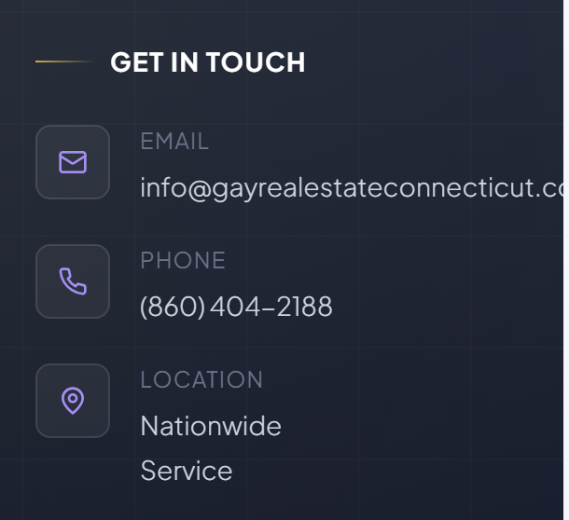

Please remove this section as well. We won’t have a general email or phone number.
I want people to reach out through the contact us section.

Here are some links that right now go back to main page, but they should go to “Contact us”:
For Buyers:
Relocation Services -> Start your relocation -> Contact Us
Buyer’s Guide -> Talk to Agent -> Contact Us
For Sellers:
Seller’s Guide -> Get a Free Valuation -> Contact Us
Marketing Your Home -> List with us -> Contact Us

I really liked this logo


We just need to change it to GayRealEstateCT.net please
Or GAYRealEstateCT.net
Which one do you think looks better?

On my page please change: “Your dedicated advocate for inclusive home buying” to “Your dedicated advocate for inclusive home buying, selling or investing”.

On all pages, can we change the color of that background on the left to something more positive, lighter? This black is too heavy and depressing. Let’s add more rainbow to it ;)
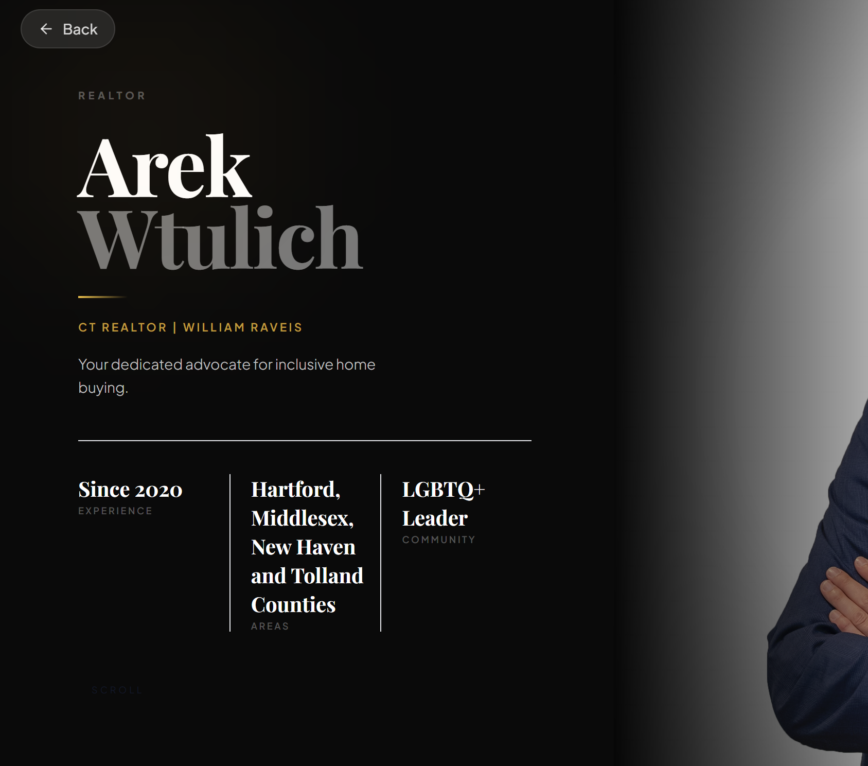

ADD HER REVIEWS

Here are reviews for Abby:
“Abby was an absolute dream of a realtor! I contacted her over a year ago when we were starting our home search. She was super responsive, supportive and helpful with the process of buying a new home. Our process got delayed a year, and when I reached back out Abby picked up right where we left off. She helped connect us with options for lenders and attorneys, always guiding the process while allowing us choices.

Abby was SO patient with our nerves about home ownership and looking for just the right home. She worked quickly to set up showings for us, gathered information about the houses we viewed and helped us think through our decisions.

We landed in our dream home much quicker than we thought we could, thanks to Abby’s diligence and expertise. I would recommend her to anyone in the area looking for a trusted, diligent, fun, encouraging realtor who they can rely on for such an important process! Abby’s the best!”
Katy H.

“We can’t say enough great things about Abby—she was an absolute lifesaver in helping us find our home while relocating from another state. Navigating a competitive market is hard enough, but doing it remotely adds an entirely different level of stress. Thankfully, Abby made it feel manageable—and even exciting.

From the start, she was incredibly responsive, thoughtful, and proactive. She took the time to understand exactly what we were looking for and consistently sent us listings that aligned with our needs and budget. She went above and beyond to accommodate our schedule and location, including virtual tours and thorough walkthroughs that made us feel like we were right there with her.

What truly set Abby apart was how much we trusted her judgment. She made smart, honest recommendations, explained every step of the process clearly, and advocated for us at every juncture. And as the process went on, she became more than just our agent—she became our friend.

We feel incredibly lucky to have worked with Abby and wouldn’t hesitate to recommend her to anyone looking for a dedicated, knowledgeable, and genuinely caring real estate partner. She helped us find more than just a house—she helped us find home.”
Mindy M.

“Since pre-pandemic my wife and I have been looking for a second home in New England. We began working with Abby about a year ago. We were sure we knew what we wanted and had a great deal of difficulty finding that. Abby helped us expand our vision and find our home. She never pressured us but showed us homes we were sure weren't the one. Turns out she was right about a home we overlooked. In addition, Abby's help and guidance throughout the process was necessary as we were out of state buyers. Thank you Abby for being there throughout the process always answering our questions or helping us find a resource. We are very grateful.”
Terri G.

“I can’t say enough positive things about Abby and how much she helped me through the home buying process. Abby is quick, efficient, knowledgeable and detail oriented. Beyond her real estate expertise Abby’s demeanor helped me feel calmer through a stressful experience and I trusted her to help lead me down the path of being a first time home buyer. Thank you Abby!”
Melissa G.

“Abby was outstanding with helping us find our forever home! She was transparent with listing prices vs. actual value of the homes we looked at. She never once pushed us towards a house that didn't fit our needs, and she remained optimistic throughout the entire process. She's a buyers dream, especially when the house is overpriced for the market. She tackled the difficult conversations with the selling agent and held to our bottom line with non negotiables. Abby rocks and I highly recommend using her for your buying or selling needs!”
Maranda C.

“This was a first time home purchase for my husband and I and to say that we were like deer in a headlight would be an extreme understatement. We met Abby while we were touring a home randomly, we hadn’t even committed to buying yet. We were expecting our first child and we wanted to get an idea of what to expect. She answered all of our questions, no matter how silly. She guided us through this whole process, explained the market in a way that helped us understand it and connected us with some great resources and referrals. We wouldn’t be home owners without her. If I ever had a question, I knew that Abby would respond immediately. If I was ever having a breakdown through the underwriting/closing process, she would calm my fears. She was a fierce advocate for us, the buyers. I would highly recommend her to anyone who is purchasing for the first time and would appreciate a great source of information to help guide them.”
Nazly B.

“As a first time renter, my partner and I were blown away with how helpful and efficient Abby was. We were able to communicate through group chat which made the process seamless, especially because my busy schedule did not allow regular phone calls or face to face meetings. She went above and beyond, even going to properties to give us a virtual tour in order to spare us the 3.5 hour drive. If you want to find your dream apartment/house, you need to enlist Abby Dudarewicz!!!”
Shawn H.

“We met Abby @ an Open House. I decided to reach out to her due to the previous realtor we were working with kinda dropped the ball.. We spoke on the phone and I let her know what we were looking for & what we wanted.Abby was absolutely amazing throughout the entire process. We live in NY so it was somewhat difficult to always go
to see a listing so she would go to do videos & send all info needed.She is very patient & extremly helpful.
We loved working with her she truly made this experience alot smoother than it would had been. She delivers!”
Daisy L.

Reviews for Carolyn:
“I couldn’t be more impressed with Carolyn’s professionalism and expertise. From start to finish, she makes the entire process smooth and stress-free. Her attention to detail, clear communication, and ability to navigate complex legal matters is outstanding. I highly recommend Carolyn to anyone in need of a top-notch real estate attorney!”
Hayden A.

“Carolyn is my go to attorney for my clients and friends. Her team is great at what they do and always put in 100%.”
Kathleen M.

“I had an excellent experience with MPF law. The staff is Kind and caring. Everyone is very knowledgeable and quick to make sure your questions are answered. I am beyond grateful. Thanks”
Matthew S.

“I had an excellent experience with this team before. I had a seamless experience purchasing a property in 2019. Now that I'm selling, I'm using them again. Terri, the paralegal, is stellar. She's extremely responsive and escalates any concern I may have through the appropriate channels. Through the first transaction, I only needed to communicate with the attorney at the closing table as Terri handled everything else I needed. Bonus: the office in Southington is beautiful. :)”
Cody B.

